Quantanite – Scrapping Phone Number

Process – Process

Definition Document Screenshots V1.0



09 March 2020



**Version Control**

|  |  |  |  |
| --- | --- | --- | --- |
| **Revision Date** | **Version** | **Author** | **Changes** |
| 01/16/2020 | 0.1 | A.K.M. Robinuzzaman, Nadimul Riead | First Draft |
| 03/09/2020 | 1.0 | Nadimul Riead, A.K.M. Robinuzzaman | Second Draft |

**Approvals**

|  |  |  |
| --- | --- | --- |
| **Name** | **Title** | **Organisation** |
| Bhavik Patel | Project Manager | Quantanite |
| Imratul Jannat | Process Owner | Quantanite |
| Abu Ashik | SME | Quantanite |

**Distribution**

|  |  |  |
| --- | --- | --- |
| **Name** | **Title** | **Organisation** |
| William Kim | CTO | Quantanite |

**Table of Contents**

Figure 1 – Navigate to Google Sheet Location 4

Figure 2 – Extracting the full address 5

Figure 2.1 – Extracting the full address 6

Figure 2.2 – Update Sheet for Missing Information 7

Figure 3 – Open Web Browser 8

Figure 4 – Search for phone number in Google 9

Figure 4.1 – If the Business is Permanently Closed 10

Figure 5 – Available phone number in Google 11

Figure 6 – Update the excel file 12

Figure 7 – Search for phone number in Yellow Page 13

Figure 8 – Available phone number in Yellow Page 14

Figure 6 – Update the excel file 15

Figure 9 – Search for phone number in Yelp 16

Figure 10 – Available phone number in Yelp 17

Figure 6 – Update the excel file 18

Figure 11 – Search for phone number in Facebook 19

Figure 12 – Available phone number in Facebook 20

Figure 6 – Update the excel file 21

Figure 13 – Search for phone number in Loopnet 22

Figure 14 – Available phone number in Loopnet 23

Figure 15 – If phone number is not available 24

Figure 16 – Email SME and Process Owner 25

# Figure 1 – Navigate to Google Sheet Location

File Location.

# Figure 2 – Extracting the full address

Desired address for searching.

# Figure 2.1 – Extracting the full address

Missing field.

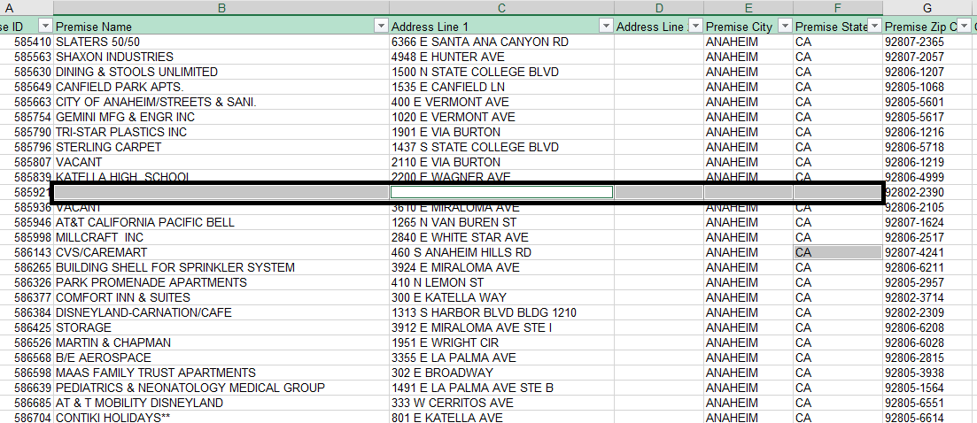

# Figure 2.2 – Update Sheet for Missing Information

Update field.

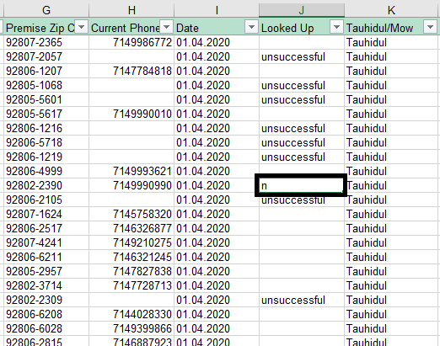

# Figure 3 – Open Web Browser

Home page of Browser.

# Figure 4 – Search for phone number in Google

Typing address on Google Search field.

# Figure 4.1 – If the Business is Permanently Closed

Permanently closed address.

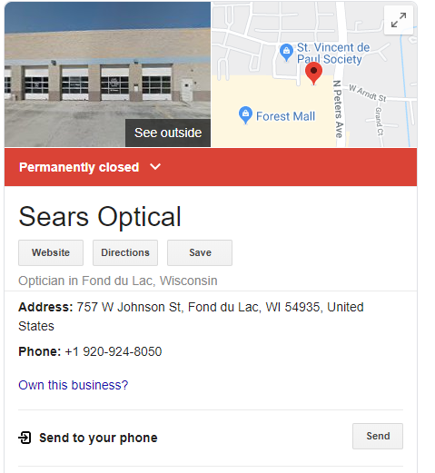

# Figure 5 – Available phone number in Google

Place of the phone number.

# Figure 6 – Update the excel file

Fields which needs to be updated.

# Figure 7 – Search for phone number in Yellow Page

Typing address.

# Figure 8 – Available phone number in Yellow Page

Phone number in Yellow Page.

# Figure 6 – Update the excel file

Fields which needs to be updated.

# Figure 9 – Search for phone number in Yelp

Typing address.

# Figure 10 – Available phone number in Yelp

Phone number in Yelp.

# Figure 6 – Update the excel file

Fields which needs to be updated.

# Figure 11 – Search for phone number in Facebook

Typing address.

# Figure 12 – Available phone number in Facebook

Phone Number available in About section

# Figure 6 – Update the excel file

Fields which needs to be updated.

# Figure 13 – Search for phone number in Loopnet

Typing address.

# Figure 14 – Available phone number in Loopnet

Phone number in LoopNet.

# Figure 15 – If phone number is not available

Updating section of the excel file.

# Figure 16 – Email SME and Process Owner

Email.

